* **Computer programming and the activities it involves.**

Computer programs are developed by computer programmers or software engineers. Computer programming encompasses a broad set of activities that include planning, coding, testing, and documenting. Most programmers participate in all of these phases of program development, but focus on the coding process. Software engineers tend to focus on designing and testing activities.

The programming process begins with a problem statement that helps you clearly define the purpose of a computer program. In the context of programming, it determines certain elements that must be manipulated to achieve a goal. A good problem statement for a computer program has three characteristics: it specifies any assumptions that define the scope of the problem; it clearly specifies the known information; it specifies when the problem has been solved.

In a problem statement, an assumption is something you accept as true in order to proceed with program planning. The known information in a problem statement is the information that you supply to the computer to help it solve a problem. After identifying the known information, a programmer must specify how to determine when the problem has been solved. Usually, this step means specifying the output you expect.

* **Programing paradigms**



It is built around the idea that programs are sequences of instructions to be executed.





It employs functions as the main driving force behind the development.





It has its foundation in math logic so program statements express facts and rules about problems within a system.





It formulates programs as a series of objects and methods that interact to perform a specific task.

* **The Types of programming languages**

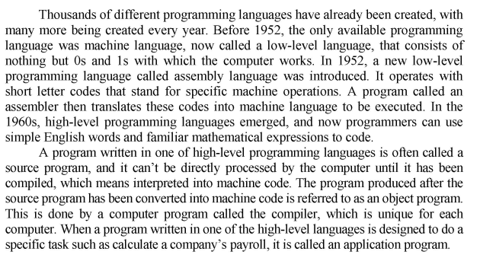

* **Object-oriented programming**

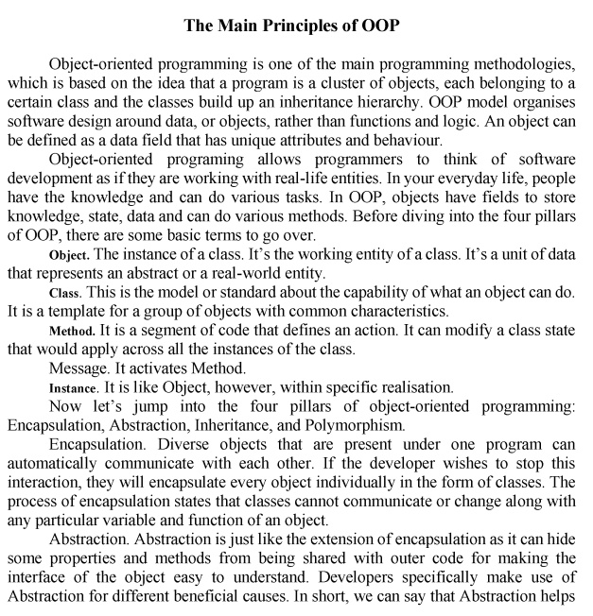



* **Programming languages in demand**

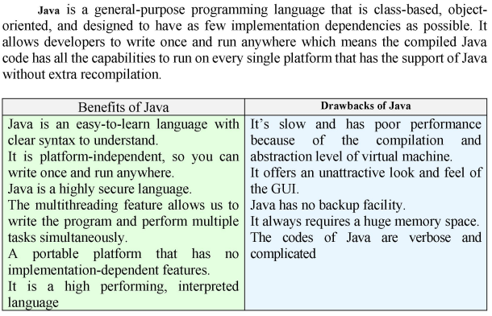 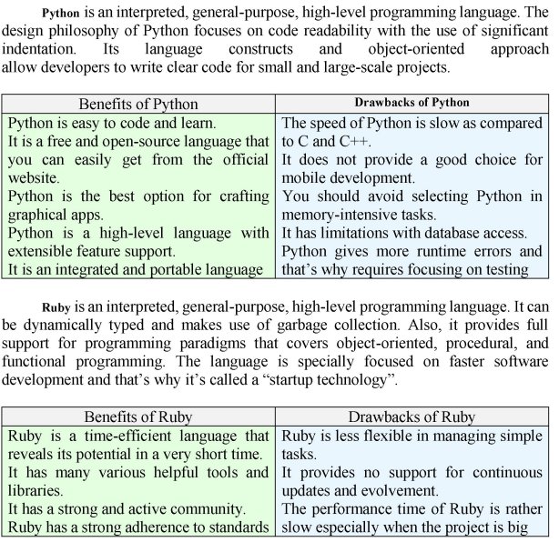

* **Artificial intelligence, its usage, advantages and disadvantages**

Artificial intelligence is a branch of computer science concerned with building smart machines capable of performing tasks that typically require human intelligence. It enables a machine to simulate human behavior. With the help of it we make intelligent systems to perform any tasks like human. The main application are Siri, Online game playing, intelligent humanoid robot. It has a very wide range of scope. Its goal is to make a smart computer system like humans to solve complex problems. It uses neural networks to analyse different factors with a structure that is similar to the human neural system. It is a program that can sense, reason, adapt, act. It is the study of training your computer to mimic human brains.

The *advantages* range from streamlining, saving time, eliminating biases, and automating repetitive tasks, just to name a few.

The *disadvantages* are things like costly implementation, potential human job loss, and lack of emotion and creativity.

AI is designed, so you don’t realise there is a computer calls the shots. The term AI was first coined by Dartmouth professor John McCarthy. And now thanks to advances in processing speeds, computer can actually make sence of all this info more quickly. The concept of AI is based on the idea of building machines capable of thinking acting and learning like humans.

* **Machine learning, Deep Learnig, Big Data**

**Machine learning** is a branch of AI based on the idea that systems can learn fron data, identify patterns and make decisions with minimal human intervention. Its goal is to allow machines to learn fron data, so that they can give accurate output. It is subtechnology which allows a machine to automatically learn fron past data without programming explicitly. With the help of of it we teach machines with data to perform a particular task and give accurate result. It has limited range of scope. The main applications are Online recommender system, Gogle search algorithm, Facebook auto friend suggestions. It provides the ability to automatically learn and improve from experience without being explicitly programmed. Its algorithms improve their performance as they are exposed to more data over time. It is a sub-branch of AI; it allows the machines to train with diverse datasets and make predictions basing on their experience/ *Working mechanism*: It utilizes automated algorithms to predict the decicions for the future and to model the functions based on the data it receives. Management: All the analisys is managed by analysts to evaluate different variables under the multiple datasets using ML algorithms. It includes speech recognition, medical diagnoses, prediction and extraction. Data points are used for analysis usually numbered in thousands.

**Deep learning** describes algorithms that analyse data with a logic structure similar to how a human would draw conclusions. It studies ways to build intelligent programs and machines that can creatively solve problems. It learns from vast amount of data. It is a subset of ML with the constant focus on achieving greater flexibility by contemplaiting the whole world as hierarchy of concepts. Working mechanism: Neural networks help in interpreting the features of data and their relationships in which important information is processed through some stages. All the algorithms are self-directed after the implementations for result fetching and data analysis. It is virtual assistants, shopping and entertainment, vision for driverless vehicles. Data points are used for analysis usually numbered in millions.

**Big data** is the newly vast amount of data that can be studied to show patterns, trends and associations. Big data is a combination of structured, semi-structured and unstructured data that organizations collect, analyze and mine for information and insights. It's used in machine learning projects, predictive modeling and other advanced analytics applications.

Systems that process and store big data have become a common component of data management architectures in organizations. They're combined with tools that support big data analytics uses. Big data is often characterized by the V's: volume (refers to the amount of data; big data deals with high volumes of data), velocity (refers to the rate at which data is received; big data streams at a high velocity, often srteaming directly into memory as opposed to being stored onto a disk), variety (refers to the wide range of data formats; big data may be structured, semi-structured or unstructured and can present as numbers, text, images, audio and more), veracity (refers to the quality and accuracy of data), value (refers to the usefulness that big data can provide for organisations).

* **The difference between VR and AR**

**Augmented Reality** is a perfect blend of the digital world and the physical elements to create an artificial environment. AR uses computer vision, mapping as well as depth tracking. This functionality allows cameras to collect, send and process data to show digital content appropriate to what any user is looking at. In AR the users physical environment is enhanced with contextually relevant digital content in real-time. You can experience AR with a smartphine or with special hardware. *Advantages*: It offers individualise learning. People can share experience over a lomg distance. It offers innovation and continuous improvement. *Disadvantages*: It features the lack of privacy. It has a low lever of performance. Extreme engagement with technology can lead to major healthcare issues such as eye problems and obecity.

**Virtual Reality** is the use of computer technology to create a simulated environment. It is used in 3D movies and video games. It helps create simulations close to the real world and immerse the viewer using computers and sensory devices like headsets and gloves. By imulating as many sences as possible, such as vision, hearing, touch and even smell VR is also used for training, education and science. VR and AR are two sides of the same coin. AR simulates artificial objects in real environment. VR creates an immersive artificial environment. *Advantages*: It creates an interactive environment. It helps you to create a realistic world so the user can explore the world. It allows users to experiment with an artificial environment. It provides immersive learning. *Disadvantages*: People start living in the unreal world instead of dealing with real-world issues. If somebody did well with simulated taske, there is still no guarantee that a person is doing well in the real world. Extreme engagement with technology can lead to major healthcare issues such as eye problems and obecity.

* **Game programming, genres, components, programming languages**

**Genres:**

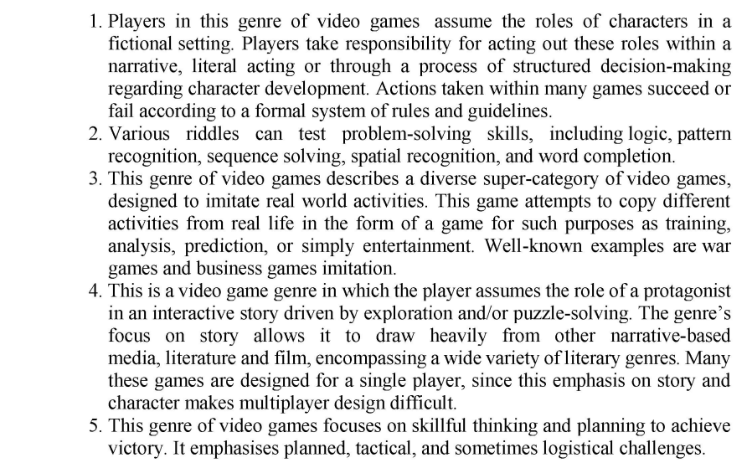

puzzle

strategy

adventure

simulator

Role-playing

**Components:**

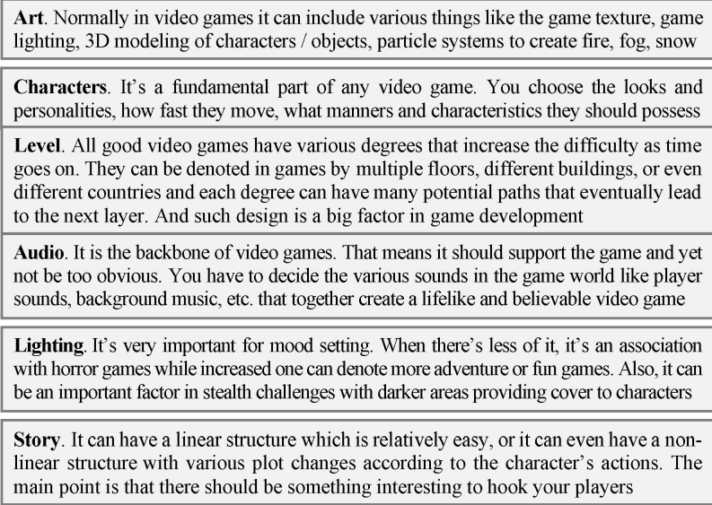

Lnguages;

